
GRIFFITH COLLEGE LIMERICK

Bachelor Degree in Computing Science
(Honours)

Marketplace for Local Artisans
Android Mobile Application

Project Proposal Form

The form, fully completed, must be returned to:

Sonia Zheleva
Faculty of Engineering, IT & Computing
Griffith College Limerick
O’Connell Avenue
Limerick

PROJECT TITLE: | Marketplace for Local Artisans  Android Mobile Application
STUDENT NAME & ID: | Valentin Gnidyi 3054010
NAME OF DEPARTMENT: | Engineering, IT & Computing
PROGRAMME | Bachelor Honours Degree in Computing Science
MOBILE NO: | +353 833840408
EMAIL ADDRESS: | 8al1krab0ta@gmail.com

PROJECT SUMMARY:

OTHER INSTITUTIONS / DEPARTMENTS / PERSONNEL ASSOCIATED WITH THE PROJECT:

FULL DESCRIPTION OF THE PROJECT:
Problem Statement & Project Background:
/,mmmmmmmmmmk
Historical Prospective:

Trading goods is one of the oldest practices in human history. Over time it has evolved from barter system (direct changing one good or services to another) to nowadays bank transactions (transfer money form one bank account to another). However, some elements from every type of trades are still in use.
To make the trading comfortable antient societies made an agreement to use some useful products for the community as a trading measure. Those products archaeologists are colling proto money. (Balassa, Bela, Bertrand 2023)

Money is concept of not direct change of goods and services. It is working as a unit of measurement, a universally recognized standard for pricing and payment accepting. Nevertheless, over time both form and way of use for money changes through history. In August 2021 was announced the oldest known, securely dated coin 640 B.C. from Ganzhuang in Henan Province, China. (Beattie, 2022) Oter coins that were found from around the globe that even older (Mesapotamian Shekel) had no date on it – which can be aged only by material and cultural analysis, which can`t provide precise answer. (Dehner, 2022)

Invention of money and it`s evolution played huge role with developing international trade. Connection with different people form different places lead to a cultural exchange. One of greatest examples of it is Great Silk Road – the system of rotes that was existing in antient Eurasian continent from Mediterranean Sea to China “Great Silk Road was not merely route for transporting goods, outstanding cultural pieces and standards of applied arts, architecture, wall painting, but music art, dance and theatrics performances of middle age.”. (Voyakin, UNESKO) And many other routes that well known history such as: The Spice Routes, Incense Route, The Amber Road, The Tea Horse Road, The Salt Route, The Trans – Saharan Trade Route, The Tin Route, were involved in shaping the culture of nations that was lived along them. (Cock-Starkley, 2020)

Industrial revolution and Arts & Crafts

The industrial revolution changed market and social value of goods tremendously by decreasing the value of human work and producing merchandise cheaper and faster. Despite this changes the mass production was not able to fulfil the market globally and request for special designed and hand-made dropped down but continue be in value. And more artists together with craftsmen start to organising into social groups such as Arts & Crafts Movement started in Britain in 1860s. The cost of production was too expensive for average family, however the society brought innovations and ideas into interior design. Also, the movement played a big role to attract society to value of genuine handmade products. (Renauld, 2023)

Mobile Payment
Providers of mobile payment solutions such as Apple Pay and Google Pay are actively competing to secure the transactions for retailers Point – Of – Sale systems. Also, there are also mobile applications that focused on such payment method such as PayPal. (Beattie, 2022)

Influence of Covid – 19
International Health Regulation Emergency Committee of the World Health Organisation declared an emergency on 30 January 2020 in relation of Covid – 19 and all made effort during the Corona pandemic to provide economic crisis, understanding its harmful affect on people`s social, environmental and health aspects. Small businesses, small industrial enterprises, micro-businesses, artists and workshops were the first, who faced the issues in productivity due to the pandemic.
(Betzler, 2020)
Automation and new technology in COVID -19

During the quarantine many people have created interesting solutions: go online, self-digitizing, using conference software, selling gift cards and vouchers in advance, start working remotely, creating for virtual platforms.
Companies are also start to automatise working environment to remove the human involvement as much as possible. Some of jobs was given to robots, some positions were optimised and changed to remote, some was given to special software and artificial intelligent machines. (Nobre, 2020)

In 2019 73% of U.K. adults purchased any type of craft, as reporting the Crafts Council in the United Kingdom, which is around 25 million items. Approximate 32 % of customers are aged under 35, showing that the younger populations as a largest group of the customers. And there are 11.620 craft businesses with 43000 employees (Craft Council 2020)

Handmade goods market expended tremendously via online e-commerce platforms. In December 2018, An American online marketplace Etsy, opened platform for artisans to trade handmade items now responses that had over 220,000 active sellers in U.K., and another company - Folksy, which focused on selling handcrafted gifts and original artwork, informing about 9,000 creators. (Chhatwal 2023)

CASE STUDIES:
Folksy is British based marketplace that focused on handmade gift products.

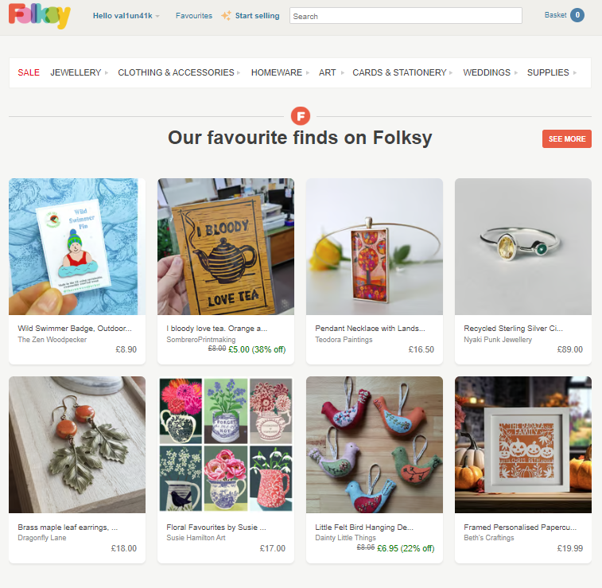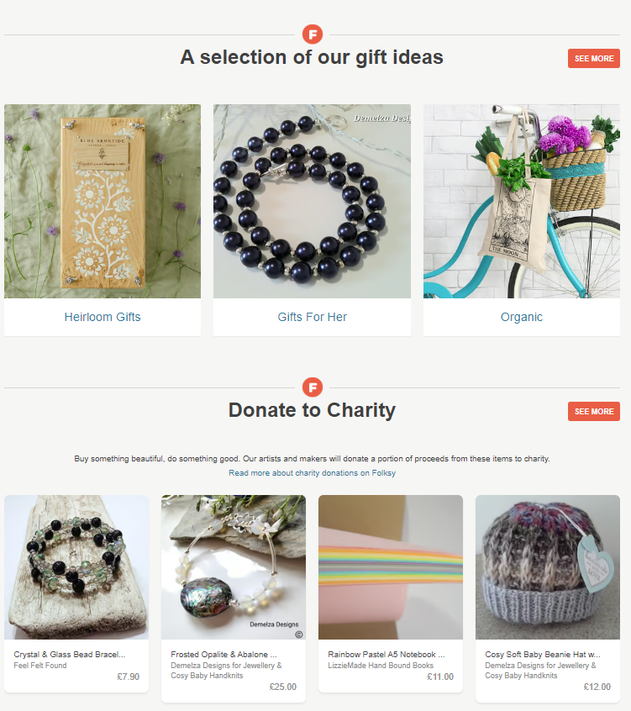
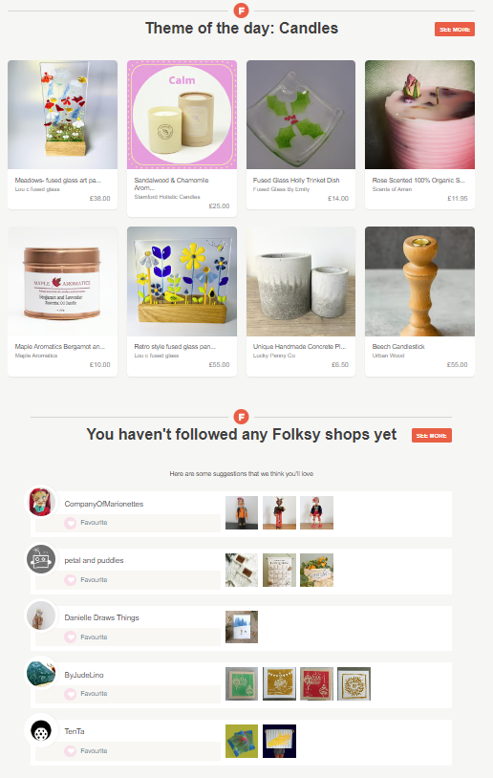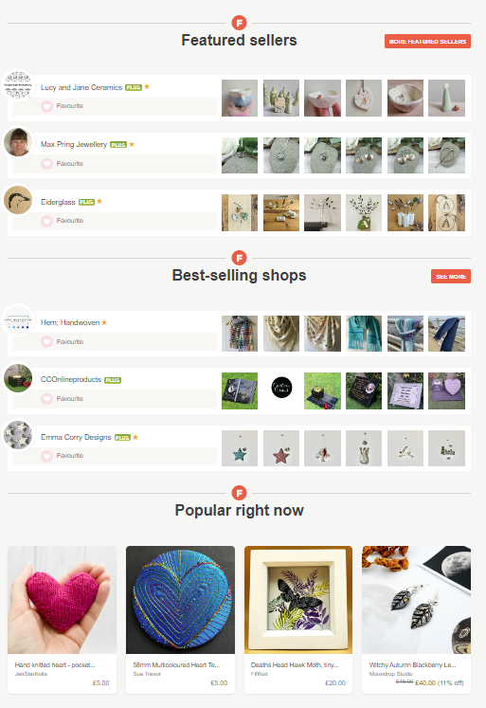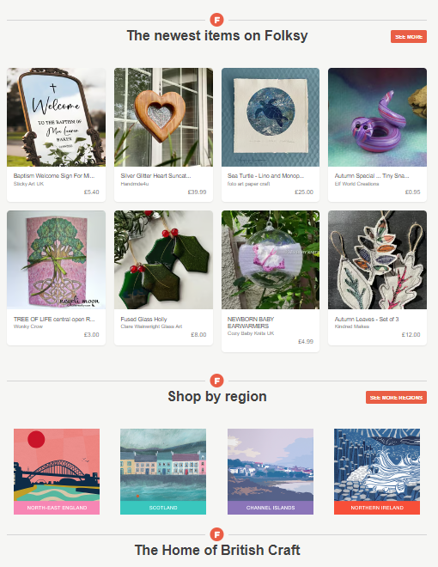
Figure 1.1 Folksy web-application main page (folksy.com)
- Pleasant design and intuitively understanding navigation.
- Showing the products by categories and listing crafted products by the author.
- Craft makers are able to select by region.
Not
- Registration online – can create fake craft maker`s account.
- Showing the artisans on a map.
- Doesn`t provides the forum chats. Only direct chat to the artisan.
- Doesn`t shows

Very inspiring design as a way of creating marketplace.

Etsy
American company that started in 2018 and based on selling handmade products from artisans.
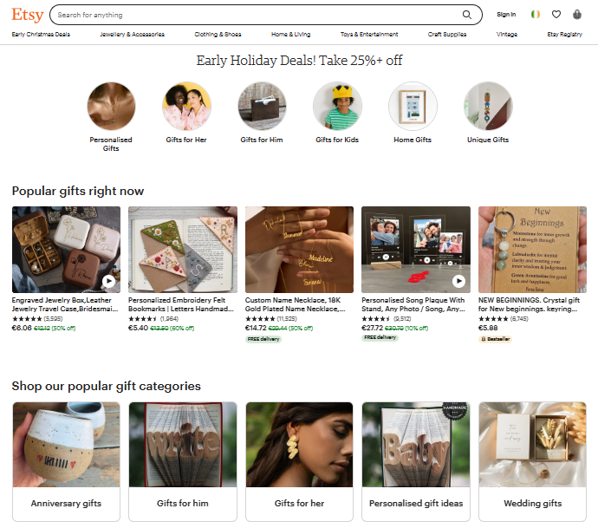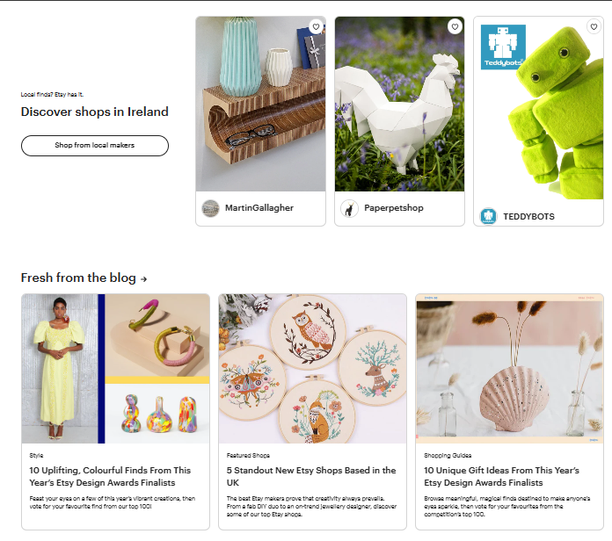
Great Profile creting :
The way of creating profile and listing product is a great example which can be implemented in the developed mobile application.
Figure 1. Eatsy Main page of web application. (Eatsy.com)

- Pleasant design
- Intuitively understanding navigation.
- Presenting blogs of artisans.
- Lising products by author and categories.
- Option to have check the list of local craft makers.

Not have:
- Map representation of local artisans.
- Calendar and listing of events for artisans in local vicinity.
- No forum chats where craft makers can share ideas. Instead of it – each able to have a personal blog.

Project Goal:

The project goal is to research about marketplaces, self-made products, art, artisans to develop a mobile application that as e-Commerce platform with social option to connect the community members in a pleasant way and empowers local artisans, support local businesses, and helps with community engagement. Provide digital platform to show and sell creators products, expend their reach. Promote the growth of the local economy by increasing sales and supporting the sustainability of small-scale, local production. Support craft maker grow by offering different features such as: user reviews, ratings and a reputation system, that able to help with continuous improvement of product and services.
The application main goal is to make a positive and listing impact on local economies, artisans and neighbours and promote unique talents and make products available with each community.

Project Scope:
The Android Mobile application will be used by general public for purchasing the unique hand-made products and also for artisans as platform for sale product and exchange of experience.

Project Objectives:

Project Methodology & Evaluation Criteria:

Evaluation Criteria:

Project & Milestones & Deliverables:

The Project Milestones are listed below:
- Generate Ideas and provide research on potential topics.
- Conduct literature review, together with Case studies of already existing marketplaces mobile applications for artisans.
- Establish goals and objectives, provide a detailed project description, and clarify project timing for the initial draft of Project proposal.
- Create and spread over artisans the Structured interview and at same time distribute over general public Survey to gather information about technologies that people are using in local vicinity for trading self-made products and what they like to see in a mobile application.
- Conduct an analysis of the survey results to determinate the potential of the proposed project and finalise Thesis Chapter 1
- Conduct in-depth Literature review on the chosen topic for the project and finish Thesis Chapter 2.
- Conduct System Analysis and develop the Conceptual model of the system, choose suitable Software Development Methodology, and finalize Thesis Chapter 3.
- Submit Thesis First draft as finished Chapter 1, Chapter 2 and Chapter 3 for review. Create short middle state presentational video.
- Gain necessary skills in Android Studio and it`s tools. Increase programming skills, become more competent with Google`s Firebase.
- Create and Program the Graphical User interface (GUI) screens together with background (Data) functionality implemented with Google`s Firebase database. Finalize Thesis Chapter 4.
- Defined Testing method suitable for the developed project and conduct Testing process of the developed application. Finish Thesis Chapter 5.
- Perform User Evaluation, critically analyse results, estimate the application and the Project success, provide conclusions and scope for future work and project and finish Theses Chapter 6.
- Submit Thesis second draft as finished Chapter 4,5 and 6.
- Prepare PowerPoint Presentation Slides.
- Combine and submit the Thesis and present the Project.

Deliverables:

Project Timeframe & Gantt Chart:
Include key timeframe, milestones, grant chart, identify risk and an RMMM matrix (Risk, Measurement, Monitor, Mitigation)
# | Milestones | Deliverables | Duration
1 | Gather ideas to identify the suitable project theme | The Project topic identified together with research method | 2 weeks
2 | Perform Literature Review related to the chosen topic for Project Proposal Writing | Project Proposal draft | 2 weeks
3 | Amend the Proposal according to Supervisor`s feedback. | Completed Project Proposal | 0.5 weeks
4 | Determine targeted audience and create questions for Survey and Structured Interview | Survey Questionnaire and Structured interview questions prepared to be distributed | 1 week
5 | Distribute along targeted audience Survey and Structured Interview questions | Results of Structured Interview and Survey are gathered and analysed. Chapter 1 if finished | 1 week
6 | Perform Literature Review;  Writing Thesis Chapter 2 | Thesis Chapter 2 completed | 2 weeks
7 | Learn Android Studio and Google`s Firebase | Gain knowledge needed for coding phase | 4 weeks
8 | Perform System Analysis and create Conceptual model;  Write Thesis Chapter 3 and submit Thesis First draft | Thesis chapter 3 completed and Thesis First Draft submitted | 1 week
9 | Create presentation video as middle point for the project | The presentation vide is submitted | 2 days
10 | Practice in improving coding skills | Become competent to code screens and functionality | 5 weeks
11 | Design and Code interface screens, data structure and desired functionality Write Thesis Chapter 4 | Desing and Coding phase are completed.  Complete Thesis Chapter 4 | 4 weeks
12 | Choose suitable testing method and perform testing on the application | Fully tested application.  Thesis Chapter 5 completed. | 2 weeks
13 | Perform User Evaluation, analyse results, estimate the project success, provide conclusion and scope of future work in Chapter 6 | Complete Thesis Chapter 6 | 1 week
14 | Submit second draft of the Thesis | Thesis chapters 4,5 and 6 completed are submitted | 1 day
15 | Prepare Power Point Presentation;  Combine the Thesis and submit | Project Presentation slides are created. The Thesis combined from drafts 1,2 and 3 | 2 weeks
16 | Submit the completed Thesis; Present the Project | Thesis submitted and project presented to examiners | 0.5 weeks

Project Risks:

No. | Risk Description | Impact | Action
1 | Time to learn new application programming languages | Critical | Dedicate time to learn programming languages early on with online tutorials
2 | Proper Project Time Management | Critical | Apply good time organisation to all Project tasks to complete the Project on time & schedule
3 | Data Loss | Critical | Backup data frequently on the Cloud and on separate disk storage devices
4 | Google Home API authorisation for interfacing | Critical | Research Google Home beforehand to find the appropriate steps to undertake integration with the application

Project Gantt Chart:

.

References:

Balassa, Bela , Bertrand, Trent J. , Allais, Maurice , Robinson, Romney and Wonnacott, Paul. "international trade". Encyclopedia Britannica, 13 Sep. 2023, https://www.britannica.com/money/topic/international-trade. [Online] Accessed 21 October 2023.

Beattie, A. (2022) The history of money: From bartering to banknotes to Bitcoin, Investopedia. [Online]Available at: https://www.investopedia.com/articles/07/roots_of_money.asp (Accessed: 21 October 2023).
Betzler, D. et al. (2020) ‘Covid-19 and the Arts and cultural sectors: Investigating countries’ contextual factors and early policy measures’, International Journal of Cultural Policy, 27(6), pp. 796–814. doi:10.1080/10286632.2020.1842383.
Cock-Starkey, C. (2020) 8 trade routes that shaped world history, Mental Floss. [Online] Available at: https://www.mentalfloss.com/article/86338/8-trade-routes-shaped-world-history (Accessed: 22 October 2023).
Crafts Council (2022) The Market for Craft. [Online] Available at: https://www.craftscouncil.org.uk/documents/880/Market_for_craft_full_report_2020.pdf (Accessed: 22 October 2023).
Chhatwal, G. (2023) The impact of ecommerce on the handmade industry., Kadence. [Online] Available at: https://kadence.com/en-us/the-impact-of-ecommerce-on-the-handmade-industry/ (Accessed: 22 October 2023).
Dehner, C. et al. (2022) The history of money: How our currency evolved from pelts to money, MintLife Blog. [Online] Available at: https://mint.intuit.com/blog/investments/the-history-of-money/ (Accessed: 22 October 2023).
Etsy - shop for handmade, vintage, custom, and unique gifts for everyone, Etsy. [Online] Available at: https://www.etsy.com/ (Accessed: 23 October 2023).
Etsy: Home, style & gifts - apps on Google Play, Google. [Online] Available at: https://play.google.com/store/apps/details?id=com.etsy.android (Accessed: 23 October 2023).
Folksy, Buy and sell handmade gifts and craft supplies from folksy - modern British craft on folksy, Folksy. [Online] Available at: https://folksy.com/ (Accessed: 23 October 2023).
Nobre, G. (2020) Creative Economy and Covid-19: technology, automation and the new economy. [Online] Available at: https://www.researchgate.net/publication/340438912_Creative_Economy_and_Covid-19_technology_automation_and_the_new_economy (Accessed: 22 October 2023).

Renauld, M.-M. (2023) The effects of the Industrial Revolution vs. Arts & Crafts Movement, TheCollector. [Online] Available at: https://www.thecollector.com/industrial-revolution-arts-and-crafts/ (Accessed: 21 October 2023).

Voyakin, D. (no date) What is the Silk Route? - UNESCO, The Great Silk Road. [Online] Available at: https://en.unesco.org/silkroad/sites/default/files/knowledge-bank-article/what%20is%20the%20silk%20route.pdf (Accessed: 22 October 2023).

Student Signature: Date:

Supervisor Signature: Date:

